Game Design Document

Fill up the Following document

1. Write the title of your project.

Tic-Tac-Toe

1. What is the goal of the game?

The player who succeeds in placing three of their marks in a diagonal, horizontal, or vertical row is the winner.

1. Write a brief story of your game?

Once there was a gentle man who lived in the darkest part of the forest. He had always lived in the forest, and in fact he had never seen either the sun or the moon. He spent the majority of his time playing tic-tac-toe in the dirt. He always played both X's and O's, because no one else lived in the darkest part of the forest. Who wants to live in a murky old forest where you never see the sun, moon, or stars?

One night, shortly after his thirty-fourth birthday, the man stood up from his tic-tac-toe game, disgusted. "This is ridiculous," he howled, "it's always a tie! No one can win this game unless the other player makes a mistake! And I never make a mistake!"

Furious, the man pushed over a nearby tree, causing a hole in the forest canopy through which he could see the full moon. Before he could say anything, the man sprouted thick hair all over his body, grew long fangs, and fleas leapt upon him. He had unknowlingly been a werewolf his entire life.

The man died shortly thereafter of an acute case of the mange.

1. Which are the playing characters of this game?

* Playing characters are the ones which respond to the user based on the input from the user
* Cars, monkeys, dinos, wizards etc, are the playing characters in the game.

|  |  |  |
| --- | --- | --- |
| Number | Character Name | What can this character do? |
| 1 |  |  |
| 2 |  |  |
| 3 |  |  |
| 4 |  |  |
| 5 |  |  |
| 6 |  |  |
| 7 |  |  |
| 8 |  |  |

1. Which are the Non Playing Characters of this game?

* Non Playing characters are the ones which don't have an action or a behaviour when the user interacts with the game.
* Hurdles, stones, bananas, coins, etc are non playing characters in the game.

|  |  |  |
| --- | --- | --- |
| Number | Character Name | What can this character do? |
| 1 |  |  |
| 2 |  |  |
| 3 |  |  |
| 4 |  |  |
| 5 |  |  |
| 6 |  |  |
| 7 |  |  |
| 8 |  |  |

Draw your imagination of this game. What does this game look like?

* Draw the game either on your computer or on paper,
* Add images of scenes of the game to show each of the playing and non-playing characters at least once.

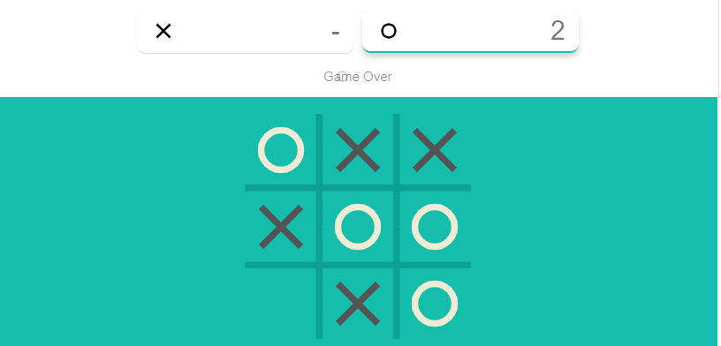

How do you plan to make your game engaging?

**Tic**-**Tac**-**Toe** is a solved **game**; unless a player makes a dumb mistake, every **game** will end in a draw. The board **game** Connect Four has been solved: The first player will always win if they make the perfect moves, regardless of what the other player does. In the **game**